# List of Lists - Python Exercise

Below is the image provided along with the recreated question, terminal output, and answer:

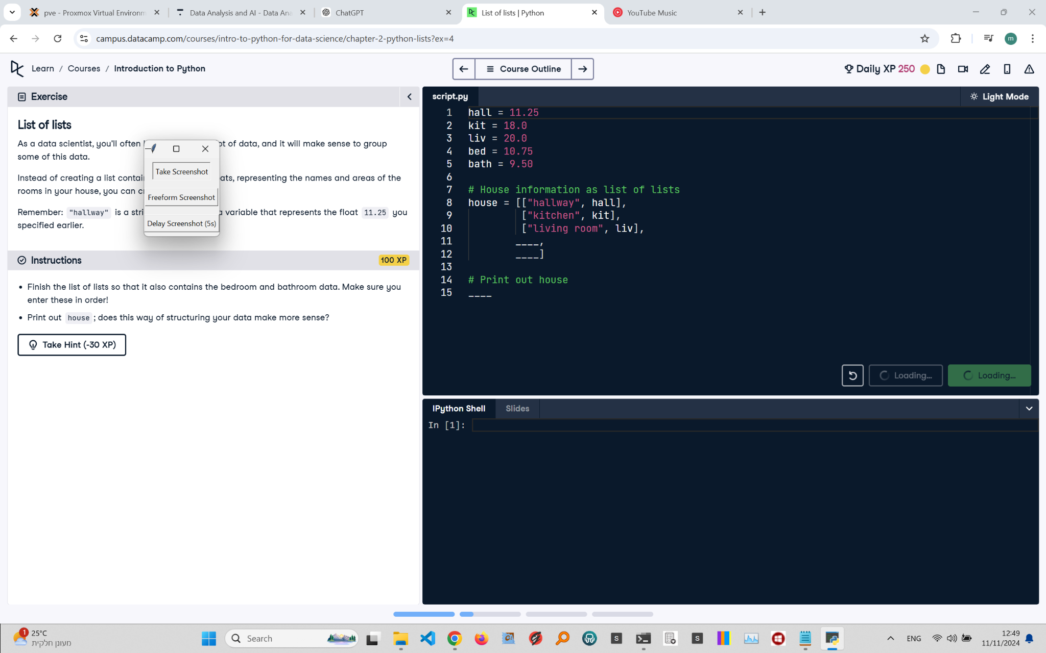

## Recreated Question and Terminal

List of Lists  
As a data scientist, you'll often work with this kind of data, and it will make sense to group some of this data.

Instead of creating a list containing simple values, you can create a list of lists, representing the names and areas of the rooms in your house in a more structured way.  
  
Remember: "hallway" is a string, while hall is a variable that represents the float 11.25 you specified earlier.  
  
Instructions:  
- Finish the list of lists so that it also contains the bedroom and bathroom data. Make sure you enter these in order!  
- Print out house; does this way of structuring your data make more sense?

## Terminal Output

Output not provided, as it is expected to match the input formatting.

## Answer

# Given areas  
hall = 11.25  
kit = 18.0  
liv = 20.0  
bed = 10.75  
bath = 9.50  
  
# House information as list of lists  
house = [["hallway", hall],  
 ["kitchen", kit],  
 ["Living room", liv],  
 ["bedroom", bed],  
 ["bathroom", bath]]  
  
# Print out house  
print(house)

## Explanation of the Answer

The code organizes room data as a list of lists, with each sublist containing the room name and its size. This structure provides better clarity and organization, making it easier to manage related data together. Printing the house variable displays the organized room names and their corresponding sizes.